|  |  |
| --- | --- |
| Image result for new york times  **The New York Times Paywall (HBS 5-512-099)**  Case Analysis | -Navya J Manepalli |

**Executive Summary:**

Newspapers were once the only medium to understand or learn what’s happening in the world. Even for searching jobs, housing, furniture etc. newspapers have played a crucial role for all the needs that one wanted. With the rise of digital world that is with the advent of internet, some of the newspaper industries have faced some serious problems. However, there are some making profits. Newspaper organizations have taken a step forward and entered the digital world. But they had to word hard to remain in the market and make what they made earlier. Now a days the world has numerous ways of media to get to know the current affairs and latest news. Some of them include face book, twitter, Instagram etc. Also, the people journalism has become much more active and updated that live telecasts have become popular. We get news from every corner these days.

Now that it has become easy to spread the news through these media, the question here is whether the news is true or not. People click pictures and record videos and upload them every second. It may so happen that the news is false. Especially with the updated technologies like photoshop, it’s important that someone authenticates the information before uploading it. Since the information is free of cost and people believe it, the printed newspapers have declined gradually. It was clear that the paper industry is having tough times getting returns on its investments. In the case, James McQuivery of Forrester Research stipulated that “The newspaper industry didn’t see monster.com taking the job portion away. They didn’t see Craigslist taking the classified portions away. They didn’t see Ford or GM making their own websites to take automotive advertising basically away forever.”

New York Times is in the top ten of the best newspapers in the US. It stands number one even today. To deal with the competition of the digital transition, when New York Times got onto the online world by having its own website. It had its trails to keep up to the speed and make profits. It started Paywalls which ran well and are still running good in the market. Though it was questionable if it could sustain with the paywalls, many of them said they would prefer paying to get quality news and stay informed.

**Analysis of Current Scenario:**

Rise in the internet created pressure for the newspaper world. The Pew Research Center reported that television was top ranked for news followed by internet. This has urged the industry to have a new model of operation by attempting to maintain the existing model along with the new model and strategies and still trying to be on the profitable end. Few stopped the print medium completely and shifted its content to online. While others followed some strategies of increasing the weekend prints and cutting down on weekdays and having content online.

For the newspaper industry to stay in the market, it has to follow the trend that its readers are looking for. But the question here is, are we still going to profit? Can we maintain both the platforms and still make profits? How well should the online content be designed? Will it be attractive to the readers? Can we be standing competition with other sources like Facebook, Twitter etc ? It was said that the online version initially did not provide any profitable revenue, nor did it increase the total circulation. When the online advertising rates were lower than the print advertising rates. Advertisements which were the main source of income has not been able to cover up for the downfall of the print subscriptions.

When the New York Times launched its website online in 1996, all the local or domestic users could access the site for free whereas the international users were charged. This increased the overseas base. In a way, having a change in the business model could be made profitable with great strategies. It was easy for people to access it with their laptops, phones and iPad. Specially to know the weather before they step out or to see if there are any offers for lunch or dinner, if there is a road block in the area etc. When the news is uploaded online, readers are allowed to comment back or share vies and spread the news. Also, since online is not a two-dimensional view, we could embed videos and click on links to other sources to know more.

**Strategies and Experiments:**

The New York Times has done some trials with its different strategic plans. Their first experimented which charged overseas readers $32 per month for websire access in 1996 has been abandoned after two years later. However, the Times was able to see increase in revenue through advertisements. After this experiment, TimesSelect was the second trial which came into picture on September 2005. Domestic readers who were able to access free of cost were imposed a charge of $49.95 for the use of certain columnists. But we couldn’t predict if this approach would remain as blogs have been in trend then. Two years later, paid subscribers increased up to 227000.After receiving criticism. The program ended on September 19, 2007.

After through research and trials, The Times management formulated the new paywall. They had four options or models to implemented as mentioned in the case. And after much debate they concluded on choosing device-specific and metered system. In which people can read 20 articles for free of cost. When this limit exceeds readers must subscribe for next access. Many readers till continued to pay as they were a fan of their content and quality. Some rules were imposed on devices like iPhone, iPad which allowed access to top news and the homepage for free. Rest were to be paid for further service.

We need to assess the preferences and advantages and disadvantages of such a strategy or business model. As alluding back to the case, for the circumstance we must survey The Times by executing the game plan of more the general population use the more income is in the case of repulsing most dedicated and dynamic customers. Is it accurate to express that they rely upon satisfying and growing the proportion of their submitted customers or would they say they are empowered concerning charming customers to deliver enhancements to site? With the complete objective to devise the right structure, The Times needs to pick its most crucial customer dependent on what they are and trusting the paywall would accomplish.

The Times attempted a “leaky paywall” as opposed to “bulletproof paywall” which had diverse limitations to content that peruses can access in vain relying upon where the clients originated from. Clients that were redirected from social networks could read the articles. However, the rule was that users from Google had 5 article per day restrain, in expansion to the 20 article per month dispensed farthest point. This way there would be able to get more members to visit the site and linking the website to other sources that could wide spread and get more users in future. And, users that read one article may share the news elsewhere and get more widespread. The organization showed their new paywall system as a success. In nine months, the supporters went up to 390,000. In any case, this increment in the quantity of endorsers can be deceiving while evaluating the manageability of the system the same number might have been lured by the initial offer of 99 pennies for a 4-week membership. We must look at the numbers beyond one year. The change in the organization revenue and subscription revenue for print and digital times from 2011 to 2017 is given in Exhibit 1 as graph.

**Exhibit 1:**

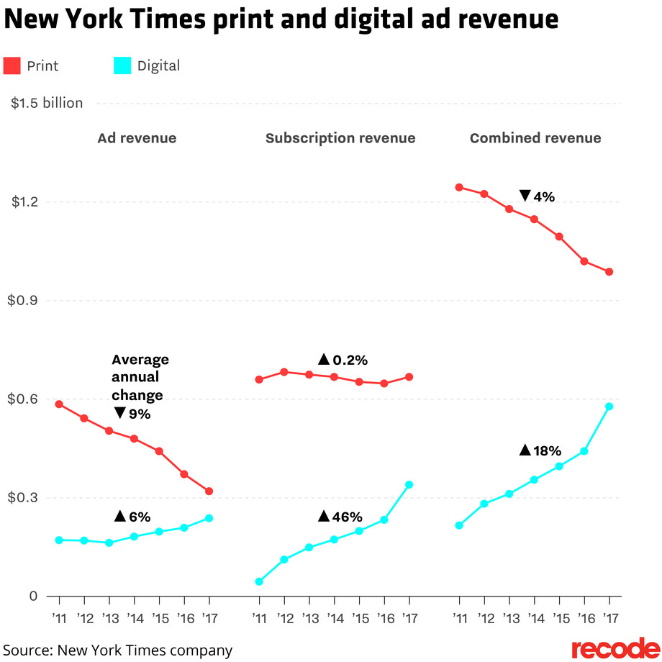

From the depiction, the online enrollment revenue of The Times has exhibited a huge addition of 46% since the use of the new paywall. Regardless of the way that the extension in online business salary has quite recently extended by a little whole, the association is so far getting more pay from online promotion reliably. This number can in like manner be depended upon to increase on account of the suffering improvement in the number of online supporters consistently. It tends to be seen from the graph that the joined income of the ad and the membership through web-based source has been developing however there was a decrease in the print income.

From the Exhibit 2 clearly the online proximity of The Times is transforming into a fundamental piece of the association's self-evident truth. Be that as it may, the print business has gone down to a negative rate. Notwithstanding how print medium is functioning The Times has 2.2 million endorsers at present. The one which could mislead us is the diverse additional parts, for example, the 2016 races, that fortified the imperativeness of the general open in the news. Consequently, it is vital to follow the advancements past a period of one year to ensure the achievability. In any case, the staggering 564% extension over a six-year time length from the 390,000 supporters in 2011 after the execution of the current paywall procedure diagrams the achievement of the paywall system for The New York Times.

**Exhibit 2:**

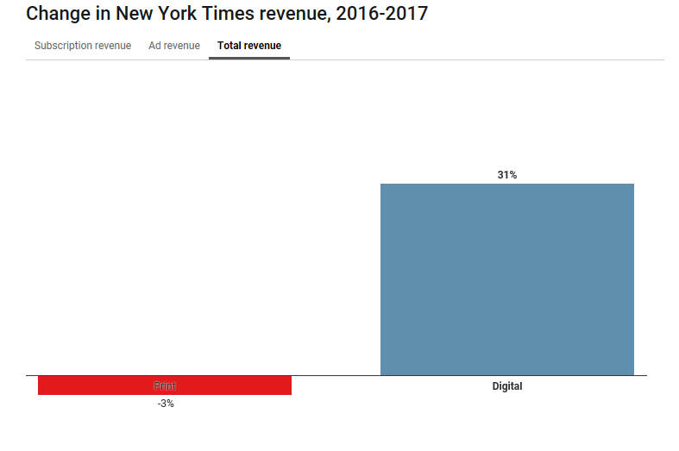

**Tactical Approach and Recommendations:**

It is evident that the paywall technique is functioning well for The New York Times. Facebook and Google have taken the digital world on its side and given the newspaper industry a tough time to get its market share. With the increasing expansion of the internet base over the past 5 to 6 years, it is important to covert the readers using this base into our customers by carefully dealing with mix of strategies. For the newspaper industry, main source of revenue is advertisements and subscriptions in this digital age. The times used to derive 75% from advertisement and now it is only 37%. Just not the advertisement revenue, the overall increase in revenue is getting hard to increase. As a positive step ahead, we need to increase the subscriber base by means of promotions and increasing the quality of the news.

Other newspapers like The Wall Street Journal faced similar issues. It has carefully planted paywall system with very strict rules. It had reached the top with its circulations and subscribers at one time. The Wall Street Journal delivered tailers and specific news reports that are not available everywhere. As mentioned in the case, the strategy used for success by the WSJ cannot be implemented by all other papers. Another paper publisher, The Sun has seen an increase in 1.9% of its readers when it ended its paywall in 2015. However, it has seen a decline in it promotion income.

Implementing the paywall system has its pros and cons. As a company, it helps you get the main source of revenue that is to be covered up from the decline of prints. The strategy should be such that, the loss of one medium should cover up by introducing a new strategy or medium. By keeping hold of subscribers to pay to access information may initially get down the subscribers, but we need to follow a strategy carefully. I think that the strategy of half articles can be implemented. That is, all readers can get access to articles only half of the content and to read the rets of it they need to pay for subscription. Also, a hybrid model of having the first few articles free of cost can be applied. We need to create curiosity in readers to read the rest of the article by modifying or creatively designing the content.

We can study the age groups interests and have specific topics for subscription and general news for free of costs. We can have coupons embedded in the newspapers to attract subscribers. In parallel, we need to get access to the news first by improving on the right resources contacts which catches the eyes of readers to be informed before anyone else. That way slowly we could make the readers addict to us and pay for the subscription. Also, we can reward the frequent readers by giving a few months subscription free or by proving offers like referral bonus etc.

By doing all of these, our focus should be maintaining the quality of the news which is the primary reason why our readers will stay with us and will be willing to pay since it is worth it.

Bibliography

The Harvard Business Case “The New York Times Paywall”

<https://www.recode.net/2018/2/8/16991090/new-york-times-digital-paywall-business-growingfast-facebook-google-newspaper-subscription>

<https://www.recode.net/2018/2/8/16991090/new-york-times-digital-paywall-business-growing-fast-facebook-google-newspaper-subscription\>

Woods, 2016, Paywall Strategy: Winners and Losers. *A look at the Wall Street Journal,*

*New*

*York Times, and The Sun*, <https://sterlingwoodsgroup.com/blog/paywall-strategy-winners-andlosers/>

<https://www.americanpressinstitute.org/publications/reports/survey-research/print-vs-digital/>

<https://www.americanpressinstitute.org/publications/reports/survey-research/paying-for-news/>